**10th Week Report**



**OJO Members:**

Abdullah Aslam: ***phone:*** *+90 (538) 050 37 64* ***email:*** *ama.abdullah90@gmail.com*

Anar Abdullayev: ***phone:*** *+90 (553) 924 96 43* ***email:*** *abdullayev.1995@gmail.com*

Bulut Ulukapi:  ***phone:*** *+90 (555) 367 26 16*  ***email:*** *ulukapi.bulut@metu.edu.tr*

Syed Saad Saif: ***phone:*** *+90 (546) 781 99 50* ***email:*** *saad.saif@metu.edu.tr*

Umut Can Serçe:***phone*:** *+90 (506) 997 99 88* ***email:*** *serce.umut@metu.edu.tr*

This week our work on the project can be summarized as follows: Holders and other parts of the chassis that designed via CAD got laser cut and became ready for the use. The work on image processing is continued and improved. Also we wrote various libraries for Arduinos, communication between Arduinos and communication between Arduino and Raspberry Pi..

**Image Processing**

After starting to implement the image processing on raspberry pi, this week we mainly focused to increase the frame rate and try different techniques for better corner detection. For corner detection we tried different combinations such as applying blur after mask, removing canny and applying blur after color detection etc. After the trials we conducted, it seems removing canny and applying blur after color detection works better. On the other hand for the frame rate improvement, we used multithreading. Lastly, for the image processing part, we tested the leaving signal part as you can also see from the following video link: <https://www.youtube.com/watch?v=RPbS2bYgumo>

**Libraries for Arduinos**

Since we decided to use two arduinos for our robot, now we have one arduino as main and the other one for sensors. For the main arduino most of the coding for maneuvers etc. was already done, we added some small libraries this week. And for the other one, sensors codes are implemented and coding for both arduinos are done. Afterwards by choosing the main arduino as slave, and the other one as master, we wrote I2C communication protocol for arduinos. With this intercommunication, our robot will perform collision avoidance, according to the data that obtain from the sensors (master arduino) and transmitted to main arduino (slave). For now, we send data byte by byte between arduinos but we are planning to send more than one byte at a time. Apart from the arduino-arduino communication, we also started working on the connection between our main arduino and raspberry pi, then we tested and verified that it works as we expect.

**Improving the Chassis**

Designing holders and other parts for the chassis of our robot is nearly done. This week we completed the designs of parts as battery holder, holder for Raspberry Pi, camera, remaining sensors, a cover for the robot and laser cut them . While updating the chassis, we also take consideration of neatness for holes and cables to make our overall robot in good order. In the below picture, there are the latest parts of the chassis.

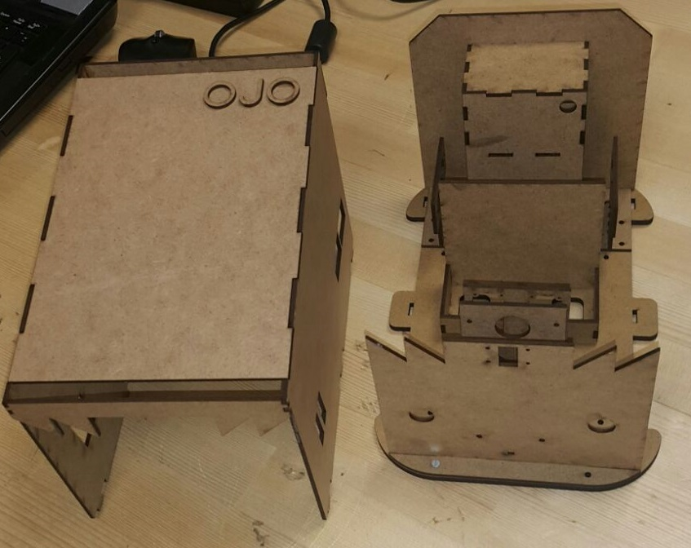

*Picture 1*: Latest parts of the chassis